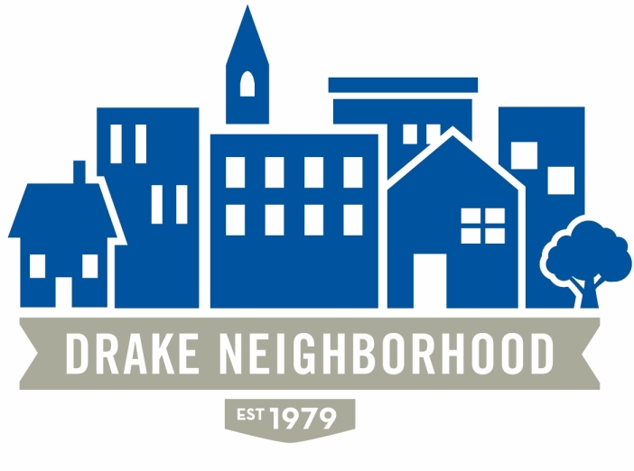
Drake Neighborhood Association Board Meeting
Wednesday, June 14, 2017
7:00 p.m. to 9:00 p.m.
Cottage Grove Presbyterian Church

Board Members Present (X)
X | Ibrahim Ali (12/18) | X | Nadia Ali (12/18) | X | Michael Christl (12/17)
X | Lori Calhoun (12/17) | X | Amy Clark (12/18) | X | David Courard-Hauri (12/17)
X | Deric Gourd (12/18) | X | Kristina Johnson (12/18) | X | Eldon McAfee (12/17)
X | Ashley Parker (12/18) | X | Eddie Robinson (12/17) | X | Nichole Aksamit Purcell (12/18)
X | Jen Sayers (12/17) | X | Mark Schneider (12/17) | X | Todd Slaymaker (12/18)
 |  | X | Mark McKinney (NBSD) |  | Anna Gleason (Student Senate Liaison)
 |  | X | Chris Reindl (NBSD) | X | Nick Valdez (Drake)

Note: All votes are in bold italics.

Introductions. There were multiple guests in attendance.
Financials: Mark gave financials.

NBSD: Calls for service were down somewhat from last month. Part 1 crimes were down a little; half were burglaries. There were also several stolen cars that were related to the burglaries (person breaks into the home and steals the car keys that most people hang by the back door). There was one call about “shots fired,” where a person said there was a gun battle going on, but it turned out to be firecrackers. Mark is very worried that these calls are going to increase significantly with the legalization of firework sales. He read from the city regulations on fireworks (you can’t set them off if you’re underage or drunk, you can only use them on July 4th between 4 and 10 pm, among other things); there is a $650 fine for violating the ordinance. A person came to the police station and threatened to “shoot all the cops,” so they’ll be keeping an eye on that.

Chris talked about some junk and debris issues that have been taken care of. The house on Cottage Grove with the party that had gunshots several months ago is now empty, so he hopes there will be more responsible tenants in the future. There was some conversation about weeds on abandoned properties. The county weed commissioner’s number is 286-3005.

Tax Sales. Mary Neiderbach (Polk County Treasurer’s office)—There are 2800 properties in the city with unpaid taxes, but the city will only take properties that are residential, have been abandoned, and are a public nuisance. There are eight properties in the City currently that meet the requirements will go up for auction later in the month; two in the Drake Neighborhood. 1161 22nd Street was sold this way and is now being worked on, as are 1070 26th Street and 1520 32nd—both former Jack Stewart properties. 2019 30th St. (in very bad shape), and 1074 26th are in the conveyance process. If you take a property through tax sale, the county will forgive back taxes, and other entities will clear debts as well. 1107 24th St. (Critelli) is another on the list that the city is hoping to be able to move through this process. 2934 Cottage Grove (where the house burned) is likely to go up for auction as well as a site where a house can get built. The tax sale is always the 3rd Monday in June.

Nelson project on University. Jen read a statement from Alexander—there has been no new design or engineering plans, but he has forwarded thoughts from our last meeting to be worked on.

Forest Avenue Project (32nd and Forest). That should be completed by the September meeting, and Kristina is hoping that we can get a tour.

Drake: Nick Valdez. The five homes south of University will be moved or demo’ed on July 24th. The University is in discussions on 1159 and maybe 1140 26th Street. Habitat for Humanity has removed most of the usable materials from the homes that will be torn down. A student group (Neighborhood Engagement Board) would like to put on a campus/community dialogue to discuss gentrification and other issues. Drake received a grant to help support student/community conversations, so if we have ideas of things that people would like to have included in these discussions, call Nick (271-2394) before the end of June.

Old Business:
- Neighborhood survey. Lori: There are a lot of people who have visited the survey site online, but not many have finished it. People did some brainstorming for how to improve participation.
- Des Moines Neighbors. Lori. The meeting focused on the new neighborhood proposed for near Gray’s Lake (just north of the river). The neighborhood would be constructed to encourage foot/bike traffic if at all possible, and is in the planning stage.
- Memorial Garden. Michael. Right now they’re trying to get the ground prepped by removing the rock and such. Now that work is being done, lots of people are coming forward with suggestions. Michael is planning a get together sometime soon to talk through all of the ideas, so get in touch with him if you are interested. Michael brought forward the fact that money is going to be needed to make improvements. Thanks to Drake student volunteers who did a lot of work, the DNA for providing breakfasts, and the Walnut Street Church for providing a huge amount of labor even though the garden isn’t in their neighborhood.
- Farmer’s Market. Michael. Michael brought one of the produce boxes that is being sold at the farmer’s market, and it looked great. You can pre-order a box by Monday and they’ll have it ready for you on Thursday. Tandem Theater and Dance will be there again this week. It’s great for kids. Fernando will be cooking tacos.
- Business Partners. Amy. She’s e-mailed and dropped in on a number of businesses in the area. The Playhouse signed up again.
- Marketing. Nichole. They put together a draft marketing plan with some slogan ideas, though they’re hoping that the survey also drives some ideas. Everyone should check out the plan so we can discuss at a future meeting.
- Kingman Island Cruise. Mac. This Saturday. All set—if you can help set up at 3:00, that would be great. They’ll be providing hamburgers, hotdogs, chips. Bring side dish to share. The band will be the Drake Combo. Jen moved that the neighborhood pay $200 for the band. Motion passed (unanimous).
- Free Flix. Jen. The movie will be at dusk on July 13th, but we need someone to help get things ready. Ashley will get in touch with Jen.

New Business:
- Nick Lensch on Edencrest in Beaverdale: they’ll be building an assisted living facility behind Boesen’s Flower Shop. They are hoping to create ways to build community between residents and neighbors, and educational activities (for example around alzheimer’s awareness and cooking for seniors). Edencrest is working in partnership with Hubbel Realty, and has several other facilities in the area. Informational meeting coming up in July 11 at 3:00 at Christophers.
- Grant. Jen. Polk County Board of Supervisors provided a $3,000 grant to be used for the survey, video, and such. This is in addition to the $2,000 seed money from NFC.
- National Night Out: Kristina and Nichole will talk at the Kingman Island Cruise.
- Storage. Kristina. We need a place to store our stuff. Some options were discussed.
Announcements:

Meeting adjourned 8:30

