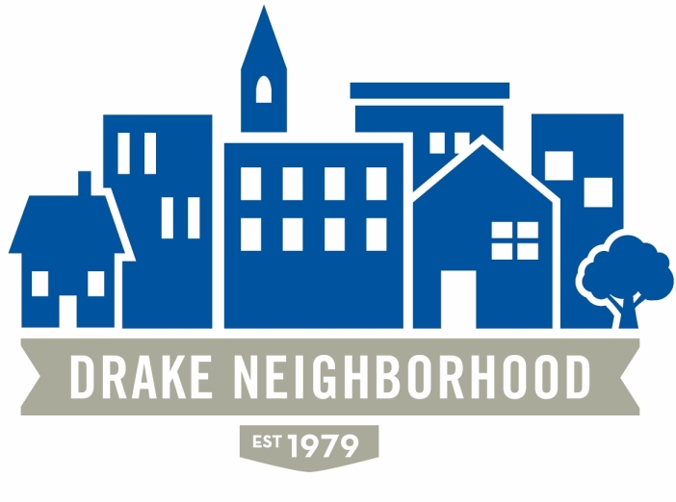
Drake Neighborhood Association Board Meeting
Wednesday, March 8, 2017
7:00 p.m. to 9:00 p.m.
Cottage Grove Presbyterian Church

Board Members Present (X)
X | Ibrahim Ali (12/18) | X | Nadia Ali (12/18) | X | Michael Christl (12/17)
X | Lori Calhoun (12/17) | X | Amy Clark (12/18) | X | David Courard-Hauri (12/17)
X | Deric Gourd (12/18) | X | Kristina Johnson (12/18) | X | Eldon McAfee (12/17)
 | Ashley Parker (12/18) |  | Eddie Robinson (12/17) | X | Nichole Aksamit Purcell (12/18)
X | Jen Sayers (12/17) | X | Mark Schneider (12/17) | X | Todd Slaymaker (12/18)
 |  | X | Mark McKinney (NBSD) |  | Anna Gleason (Student Senate Liaison)
 |  | X | Chris Reindl (NBSD) | X | Nick Valdez (Drake)

Note: All votes are in bold italics.

Introductions: There was a large turnout.

Minutes: February minutes approval moved by Deric, approved.
Financials: None.
Board took a moment of silence for Sean Haire, a former Board Member.
Reports:
- NBSD: There was a shooting between 30th & 31st on Cottage Grove this past week. It is under investigation. Sgt. McKinney has spoken with the landlord and tenants. There was a party put on by Drake students that included non-Drake residents, and apparently there was an altercation between the latter.
Burglaries are standing out in the monthly stats with a couple of clusters. There were a total of 10 for the month. Any time you see someone suspicious that you don’t know, who is maybe lingering or very unfamiliar, feel free to call the police—they can help if the person is lost or needs help, but can also identify the person if they don’t belong. They can’t help if you don’t call. There were 633 calls for service, and that number includes a lot of things like barking dogs, medical calls, and so on. If you call them and the circumstances change, call again—if the priority level changes they might dispatch someone more rapidly.
Going back to the shooting, a resident said she has called about disturbances in the middle of the night, but was told that if you don’t see fighting—just hear yelling—then they can’t do anything. Mark said that if you feel like you aren’t getting a satisfactory response, ask to speak with the supervisor, and they will respond accordingly. Another resident said this was not an isolated incident—they’ve been dealing with problems at that property for a couple of years now. She brought pictures of extremely large parties, messes after the party in her driveway, uncollected trash in the yard, and so on. She said after she confronted the residents, her pickup truck was vandalized (black tar was put on her tires). She said that the residents have a loose pit-bull at times, and a previous tenant had two loose dogs that attacked and killed her dog, leading to a court case. She said her concern is that it’s ongoing and escalating, and that these issues all pre-dated the shooting. Jerry Parker from Drake spoke, saying he understood her frustrations. The message he relayed to the students was that Drake will not accept this behavior. They want their students to be respectful of the neighborhood. He said that if something is going on around the neighborhood, call both 911 and Drake Public Safety. He said they will be addressing the situation and that they expect more of their students. Half of the student population is living in the neighborhood, and that they have to be good neighbors. You can call Drake Public Safety at: 271-2222. Jerry’s direct number is 271-4088. Cell number 319-217-2411. If it’s impacting the quality of your life, Drake wants to know about that.
The landlord (Matt Sayhag) spoke about his plans to handle the issue. He wanted to give a little background information, and let us know what he has done in response. He said that he has lived in the community for 18 years, since coming to Drake as an undergrad (later law). The school is a big part of his life, as is the neighborhood. He practices real estate law. He owns more than just this property in town, running a rental business. Before he bought this particular house, it was about to go on foreclosure, and so it was a short sale. When he acquired the house, it was in poor condition. He said they probably put $20K into the house, painting the exterior and cleaning up the shrubbery, and so on. He explained this to point out that he has a financial stake in the property. When rental applications come to him, he says that who the people are is important to him. For example, he likes to rent to Drake students; it doesn’t usually make him nervous. When he heard about the issue, he said he tried to be pro-active. Kristina asked what has happened/will be happening with the current tenants. He said he has talked to the tenants and does not have clear evidence of the clear and present danger, and so cannot legally evict the tenants. There was a lot of frustration among the residents at the meeting, and audience members expressed that this was not an isolated incident.

The commander of the NBSD program also addressed the group, saying that we can get in touch with him if we need to.

- Drake: April 23rd-29th is Relays. Downtown street painting will not happen this year, but hopefully something will happen next year. A student group did a survey of Drake students on student perceptions of the neighborhood, and they’ll share them with us when they have findings. Jazz in July: Friday, July 1st will be at Drake, they hope. The University Avenue Project is still in negotiations, so nothing new to report there. Only one person proposed to move a house, so that may happen. They will need to demolish the other four homes. When they do that, they will invite Habitat for Humanity to come do the salvage.

- Mayor Cownie and Councilman Gray spoke about the budget. They had a 12 cent increase to property taxes, and said that they’re working on walkability, safety, sustainability, and other things. Mayor Cownie mentioned the bill to regionalize the Des Moines WaterWorks. A previous bill had proposed to give DSM 2 votes out of 17, and the bill was rejected. After the election, they felt that things changed both in DC and in the Statehouse. WaterWorks lost on all four counts before the Iowa Supreme Court, and some of the language in that verdict gave Mayor Cownie great concern. He expressed deep confidence in DSM WaterWorks, but wanted people to understand that the situation is a difficult one, which is why the city is grudgingly supporting the bill.
Gray spoke about the transportation plan. He wants to get the University Ave streetscaping done. We need a route through the neighborhood. They are quite focused on those changes. A lot of construction is going on that ought to be very nice. Josh Mandelbaum spoke, saying that if the legislation passes then the City Council will have a chance to push the lawsuit forward. He argued that City Council should do so. Michael Christl said he thought that the feedback meeting on the budget that Mayor Cownie held was spectacular. Kristina passed around the sidewalk replacement schedule.
Old Business:
- Laurie is working to get the Drake Neighborhood Survey on the web. They were going to go out into the neighborhood to get the survey out there, and she asked people to send her names if you’re interested in doing that. Deric said he thought it was a great opportunity to engage neighbors.
- Michael spoke about the memorial garden (Cottage Grove and 25th) and things are moving forward with some Drake students working on designing changes to make it a very welcoming spot. Saturday, May 6th will be the workday, so let Michael know if you’re interested.
- Nichole has been working on website updates. Membership info has all been updated. When PayPal is working again that will be put up there. She’ll be reaching out to people about the pages that currently exist. She’s been updating both Nextdoor and Facebook. She’s also been working with Jen and Nadia and Justin on the library project to highlight cool things that have happened. If you have anything that you want to put into the April newsletter, let her know! Membership dues are $20 for a year, $80 for five years.
- Todd has been doing research for the website. We don’t have the login information for some of the software that we need. Michael moved to pay the $89 to get the software ourselves, Jennifer seconded, and the motion passed.
- Lori: there will be a meeting of Des Moines Neighbors at 6:30 at Smokey Row to discuss the WaterWorks issue.
- Michael on the Farmer’s Market. The new board will be Nadia, Lori, Suzanne Stewart, and Michael. They will be working on it and get us new information soon.
New Business:
- Abbey from Orchard Place came. They work with kids (primarily high schoolers) who have delinquency issues. Whether they need to do community service, restitution, or other things, Orchard Place works with them. They really like doing neighborhood projects. Projects are always supervised, and kids come from an array of levels of probation. They’ve helped with beautification, road walks/races, and so on. She handed out some pamphlets, but also said to let them know if we have projects for them. People suggested help with the surveys, National Night Out, beautification, and others.
- Jerry Parker: Polk County Crisis asked for our support on a program called “Raise the Bar,” which is a project to provide training to reduce sexual harassment/violence issues. Deric moved that we express support for the Raise the Bar initiative, there were multiple seconds, motion passed.
- Amanda Martin from Drake’s Office of Community Engagement wanted to share about the engaged citizen program. Drake was one of three colleges and universities to receive a grant to support an “academic service year” for first-year students. Students will commit to 8 hours of service per week. She thinks that there will be a lot of benefits. Cost-share of $1,750 to the partner (students get paid $3,500, and there is a housing benefit). In the first year, they learned that 15-20 hours per week was too much for first-year students, but other than that they found it to be a very beneficial program. There was interest among board members for taking part.
- Kristina asked if DNA was interested in doing a water station for Drake Relays, but we couldn’t get a group together, so declined.
- Free Flicks. They have suggested Thursday, July 13th, and the board supported that date. Jen will send the new releases to the Board.
- Rodine Mickel Dinner. It’s an award dinner put on by Des Moines Neighbors, and Kristina asked if anyone had any nominees. Kristina, Jen, and Nadia will work on the nominations (due the 22nd)
- 49th and University used to have a streetcar turnaround (just east of Waveland Golf Course). They want to distinguish this as historic preservation, with an informational sign. Deric moved that DNA support Waveland Park’s Historic Preservation goals, Mark seconded, motion passed.
- Supervisor Connelly has been invited to attend our May meeting. Let Kristina know if we have a particular issue that we’d like to discuss.
- Pastor Andy introduced himself and welcomed the DNA to the church. He talked about many of the exciting things the congregation is doing.

Meeting adjourned 9:09

