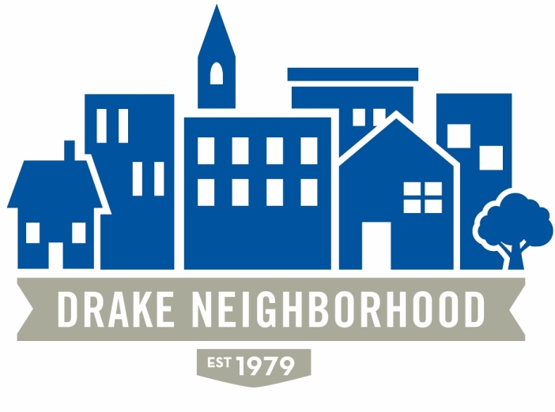
Drake Neighborhood Association Board Meeting
Wednesday, May 10, 2017
7:00 p.m. to 9:00 p.m.
Cottage Grove Presbyterian Church

Board Members Present (X)
X | Ibrahim Ali (12/18) | X | Nadia Ali (12/18) | X | Michael Christl (12/17)
X | Lori Calhoun (12/17) | X | Amy Clark (12/18) | X | David Courard-Hauri (12/17)
X | Deric Gourd (12/18) | X | Kristina Johnson (12/18) | X | Eldon McAfee (12/17)
 | Ashley Parker (12/18) | X | Eddie Robinson (12/17) | X | Nichole Aksamit Purcell (12/18)
X | Jen Sayers (12/17) | X | Mark Schneider (12/17) | X | Todd Slaymaker (12/18)
 |  | X | Mark McKinney (NBSD) |  | Anna Gleason (Student Senate Liaison)
 |  |  | Chris Reindl (NBSD) | X | Nick Valdez (Drake)

Note: All votes are in bold italics.

Introductions. There were 11 guests in attendance.
Minutes: Mark moved approval of April minutes, minutes passed
Financials: Mark gave financials.

NBSD: Calls for service have gone up with the temps. Part 1 crimes have gone up (132-190), 5 shots fired, homicide at 3500 block of University. The homicide seemed random, no leads right now, they’re waiting for people to come forward with more information. There don’t seem to be any patterns to the increases. He thinks that fireworks are going to increase concern about shots fired in the city. People currently confuse them a lot. In other news, some students had tried to close streets for a block party using the DNA logo, so it had been approved, but got taken away once people realized what had happened. Drake U, NBSD, and the DNA all worked together quite well on that. Relays was relatively uneventful this year. Mac asked about panhandlers off the highway. Mark said that this is a problem because there are traffic accidents caused by doing that, so you should call them in. They try to be understanding at first.

One guest said there had been three murders within four blocks of his house in the last two years, and wanted to get more information about what was going on. Mark said that a lot of news reports are based on speculation. If you call him, he’ll tell you whatever he can. But as far as Mark can tell, there’s nothing tying them together. The vast majority of homicides happen for a reason (the people know each other). They are up significantly (14 so far is quite high for Des Moines). Jen said that maybe people could start up neighborhood watches. Mark said that one important thing to do is call in things like domestic fighting. That often escalates. If you see cars driving around many times, call those in as well. If a person is lost, he can help, but if they don’t belong, he can move them along. Don’t be afraid to call—it doesn’t waste his time. Call him directly before 5:00, but feel free to call dispatch as well. They will prioritize, so don’t worry if it feels minor. 283-4811 is the “general” dispatch number that you can call for non-emergency stuff. Todd asked about the number of motorized vehicles on bike trails. Mark said to call the municipality where you are and let them know (say, Polk County if you’re outside of city limits).

Drake: Nick Valdez: Relays was quiet and cold, but went well. The state track meet will be the 18th-20th, and that gets more visitors than Relays. The Michael Garden has been cleared and prepped. Drake will be helping the farmer’s market out by bringing some tents and a little bit of funding to NFC.
.

Old Business: Scheduled: 30-45 minutes. Actual: 75 mins.
- Survey—Lori. They’re trying to get out the paper copies. There are some online ones.
- Des Moines Neighbors meeting—Lori—No meeting this month (due to the dinner)
- Michael’s Garden—Michael; Memorial for Sean and Cyndi. There were 18 Drake orientation leaders there, and they removed a huge amount of rock and some other things that would make it difficult to do the planting and layout that has been planned (design by Kevin Venhaus). The garden will be maintained according to a community calendar that will be on the web. Students had great feedback—they really enjoyed the work. They had lunch at Woody’s afterwards, and the students on the community engagement board asked the orientation leaders questions about their perspectives of the neighborhood. Students reported really loving their conversations with residents Marty, Allison, and Grant learning about why those people love the neighborhood and the project. The next work day will be the 29th of May from 7-noon.
- Farmers’ Market-update—Michael. The first one will be June 1, sponsored by NFC. Nicole from NFC said there will be local chefs, David Young, Chris Hensley, John Mauro will all be there. NFC will present parts of the book that their director had a piece in, so that should be fun. If you register for the event, you will get a free drink ticket! Registering will help them to get a sense of how many people will be there. She invited the DNA to come table there. Michael said that the mission of the farmer’s market is to get fruits and vegetables into the hands of people who need them. There will be a farmer’s market health box that you could say ahead of time you wanted, and they’d have the box ready for you at the market. They received a “Double-Up Food Bucks” grant from the USDA that allows people to double the value of SNAP benefits by buying healthy food so that money can go even farther. Michael said that they really need all hands on deck—as many DNA members to help as possible. A guest asked whether it might be possible to donate a health box, and Michael said that sounded like a great idea.
- NFC—Nicole from NFC said there are three videos up on their facebook page that are great to watch. One thing they did was create a low-interest home improvement loan. That gives them a little more flexibility with the guidelines to help people do home improvements without having to meet a particular credit score. People haven’t been doing this as much as they had expected, so they made a portion forgivable. “Project Reinvest” came out of a Bank of America settlement, and NFC is the approved lender for Polk County. Any homebuyers can get a deferred loan for $10,500 to help with the down payment. Those can go to anyone at 100% of median income or below. They’re working to get lenders to participate, so this will be going live soon. You have to pay back the money if you refinance or sell the house.
- Business Partners Program—Amy. They’ll meet with some partners starting this Monday. They figure that they will give a pro-rated membership to new members.
- Marketing update—Nichole. Newsletter went out just ahead of Relays. They’ve posted the survey on Facebook and NextDoor. There should be a list of neighborhood events to be e-blasted out in a couple of weeks. She was also hoping that we could print some flyers for the farmer’s market. There will be a promotional video, and she wanted to know whether there might be some budget available. There is a grant that we have that can help with that. Also, they need photographers! Take pictures of fun things in the neighborhood. They’re trying to rebuild the DNA photo library that they can use for facebook, the web, and so on. KJ said that we would also like to start a project where people could take pictures of things their neighbors are doing, and then the neighbor can win an award.
- 31st Street Cleanup—Mac. Amy, Mac, Lynn Swanson, and Marlene Vickstrom cleaned up 31st between University and the Freeway on the Tuesday before relays. They could also do that before the state track meet as well.
- Kingman Island Cruise—June 17. 4-7 pm. Mac. We’ll be doing Kingman Island Cruise again this year on June 17th, closing the street, and so on. He’ll have a budget at our next meeting. DNA will provide burgers, hot dogs, and chips. The rest will be pot-luck.

New Business: 15-30 minutes
- Michael: Talk about food trucks/areas to approve--update. They’re waiting for a response from DART before sending the letter. They’re thinking that Forest might not be a great place with construction and such, so maybe there’s a better place to do it. So they’re thinking University and 24th Street going south.
- Memorial Day Weekend volunteers need jobs—Jen. There are volunteers interested in working in the neighborhood. Maybe we can have some of them work in the garden, others taking pictures. Jen will get together with Michael and Nichole.
- Forestdale garage sale is June 10 from 8-2. This is a nice annual event.
- Forestdale Fourth of July approve $100 for sound permit. All board members invited. Parade starts at 10. Potluck at noon. Bring meat, beverages and a dish to share. Dave Zollo plays from 4-7. Jen moved approval, Mark seconded, motion passed. (unanimous).
- Check for Rodine Mickell dinner to DSM Neighbors. KJ suggested giving a check to Des Moines Neighbors for that (there were five attendees). We did not give money last year. KJ suggested $50. Deric moved approval, Mark seconded, motion passed (unanimous)
- KJ was contacted about whether we wanted to do an event at Drake next year. There had been some talk about whether that would make sense for National Night Out, but she felt that it made more sense at Drake Park. So this might be something different.
- A resident contacted KJ about getting a HAWK signal (crosswalk) between 31st and 42nd. KJ thought 35th might make sense. There was some conversation about what to do, and where best to put it.
- Drake Park vandalism: spread the word that we should be monitoring the park. If you see anything, let the policy know. Deric says that it is happening during the day. If we can’t get the problem fixed, the Parks Department is getting very frustrated with the problem.
- Alexander from Nelson construction to present University Development. Jen will be the liaison with Alexander at Nelson construction, and KJ will be the liaison with Drake. He wanted to start with some disclaimers. First—there are a lot of pictures that have been in the paper, but the project is not nearly as far along as it looks in the pictures. Next, there will be a traffic study, with a third-party consultant hired by the city. With those out of the way, the reason that they haven’t come to the neighborhood already is that it was a competitive process, so it wasn’t their project before now. Drake is contracted to provide Nelson with a clean site by October, so they will have to move or tear down five of the houses in that region.
There are two parcels there, and they are now going to start designing the buildings. Project 1 is apartments and retail; Project 2 is the hotel; Project 3 is a row of townhomes. These will be constructed as independent projects. He wants it to be clear that there are no blueprints or anything. They will announce the timelines for each project by fall at the latest.
Deric asked about the alley between 25th and 26th, which he said gets a fair amount of use. He was worried that capping off alleys exacerbates crime problems if there isn’t an outlet. A number of people were concerned about keeping that alley open. A resident asked how they chose the types of things to do. Alexander said that they have a lot of experience with hotels and thought there was a gap in the market for that. They also thought there’s a lot of demand for mixed use with retail in the area. Part of the idea with market-rate apartments is that they were hoping that not having more student housing would keep activity around campus in the summers. They will try to keep local retailers in the building, but will rent to national chains if they can’t fill with local. They’re thinking 130 rooms for the hotel. A resident asked where the cars will park. They anticipate business travelers and university traffic, so he thinks they probably won’t all need parking. There will be options for valet parking, and a parking lot. Both projects will be a maximum of 4 stories. They won’t be tapering the building, but having the parking lot between the houses and the hotel. On the other side, there will be row homes transitioning to the neighborhood. The center of Project 2 will be greenspace for water infiltration. A resident asked how long the construction process is likely to take. Alexander said that it will probably take 12-15 months per project, maybe 18-20 months for the whole series. There will be a couple of months where it’s particularly noisy, but he didn’t think it would be a big deal during most of the time.
There are deed restrictions on what can’t be done: vape shops, adult, bar size, etc. There will be about 10,000 square feet of retail. That’s probably 3-5 retailers. There will be a 5,000 square foot restaurant with the hotel.
There was concern about the design looking like “mid-century modern,” and a fair amount of conversation about design styles.

Announcements:

Meeting adjourned 8:30

