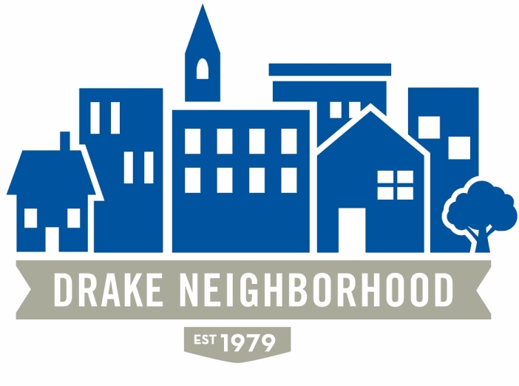
Board of Directors Meeting
Wednesday, November 11, 2015
7:00 p.m. to 9:00 p.m.
St. Catherine of Sienna, Drake University

Board Members Present (X); term expires as noted
 | Kevin Altaus (12/31/16) |  | Emily Blobaum (12/31/16) | X | David Courard-Hauri (12/31/15)
 | Patty Daniels (12/31/16) |  |  | X | Deric Gourd (12/31/16)
X | Kristina Johnson (12/31/16) |  | Scott Johnson (12/31/15) | X | Sean Haire (12/31/2016)
X | Eldon McAfee (12/31/15) | X | Eddie Robinson (12/31/15) |  | Jen Sayers (12/31/15)
X | Mark Schneider (12/31/15) | X | Todd Slaymaker (12/31/16) |  | Krysta Thomason (Student Senate Liaison)
X | Mark McKinney (NBSD) |  | Chris Reindl (NBSD) | X | Renee Sedlacek (Drake)

Introductions (5 Min.) Visitors: Lori Calhoun.

Consent Agenda (5 Min.)
- Approval of Minutes September and October: Deric moves, Eddie seconds, minutes approved.
- Monthly Financials: None

Reports (15 Min.)
- NBSD Saturday will be crazy with the debates--don’t try to go anywhere on Saturday on University Ave! There was a neighborhood workshop on crime on the 10th. Drake was down about 1% in major crimes this past year. There was a shooting this past weekend at 3120 Cottage Grove. There seems to have been more shootings recently, but there hasn’t been any connection between them, so they do not appear to be any kind of trend. There was a recent meeting between Drake students, Ako Abdul-Samad, and others, where students indicated a desire to get more involved with the neighborhood, rather than just doing things like cleaning up alleys, but actually working with people. It seems like there is a lot of potential there. 1221 22nd Street, the people who have been causing a lot of the issues are gone, and the house is boarded up. Things are much more quiet there now. Chris will be out of town until next week.

- Drake University. Parking during the debate will be difficult. Yahoo, CBS, CNN, etc are all on campus, and more are coming. You’ll need credentials to get into Cole hall starting Friday. Drake has had a limited number of tickets to get into the debates. There was a lottery system with 1200 people taking places—all of those tickets have been distributed. The Sanders campaign will be holding a watch party at the Varsity, and some Drake environmental folks are organizing a watch party at the First Christian Church. The Harkin Institute will also be bringing in a lot of interesting speakers as well. We have a lot of great opportunities in the neighborhood, so take advantage of them!

4 out of 5 games have been played, and 123 neighborhood passes have been redeemed, others at women’s volleyball, soccer, and so on. Of the 3200 passes sent out, 39 individual passes have been redeemed, so Renee would like to encourage us to use them more! We expect to see more during basketball season.

One year from now, Drake will be launching a first year service program wrapped around the curriculum, and they’ll be looking for organizations that they can do long-term service projects with for the entire 9-month period. They need 5-10 organizations who will want to participate. There will be a cost share of $3500 per student for the year. In the spring, they’ll want to bring the agencies together, and we’ll develop the curriculum as a group—the organization, faculty, Drake, and so on. Engaged Citizen Corps. Organizations need to be 501c3, but the funder doesn’t need to be.

- Old Business. Deric: no new news on the sidewalk violations. Storage options? No new news on that either, or on the website.

New Business:

- Monday at City Council they spoke about the Streetscape docket, and Drake is on the list. There are four that they have been working on. The City has not decided yet how they will be applying for funding, but we may want to revisit our plans so we can move up on the list. We might not be ready to raise the funding right now, but we will need to be ready when they ask us.
- Yearly planning meeting: Kristina will send out a Doodle poll for our January meeting soon.
- New Board members? Election will be in December. Lori Calhoun expressed interest. Renee suggested that we speak with the Principle at King (Peter LeBlanc), or Community Youth Concepts might be able to help us. CCI might be a good contact as well.
- Articles for the newsletter need to be in by December 1.
- KJ received an e-mail from the pastor at the New Life Center, who has been speaking with people who are interested in renewing the Drake Park Neighborhood. Their main concern is that they have a meeting on the same night.
- Mac tries to keep an eye on 31st Street, as one of the main entryways to our neighborhood. When garbage pickup is on Fridays, visitors often see the trash cans out by the street on the weekends. He wondered whether it would be possible to switch pickup to a different day?
- Deric brought up that 1161 22nd St is currently owned by Home Inc. Unfortunately, because of the funding that Home Inc gets, they can’t really rehab the home. They’re looking to sell it very cheaply to a certified rehabber in order to get it taken care of. If they can’t sell it within the next few months, it will be torn down. They’ve contacted a number of people, but there’s been no serious interest. If anyone knows anybody who might be interested, let Deric know and he’ll pass the information along.

Adjourn Business Meeting

