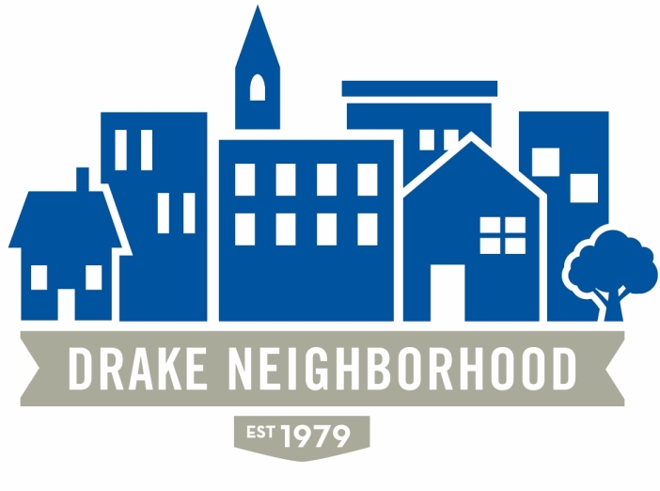
Board of Directors Meeting
Wednesday, January 11, 2017
7:00 p.m. to 9:00 p.m.
St. Catherine of Sienna, Drake University

Board Members Present (X)
X | Nichole Aksamit Purcell | X | David Courard-Hauri | X | Ashley Parker
X | Amy Clark |  | Nadia Ali |  | Kristina Johnson
X | Deric Gourd | X | Mark Schneider | X | Eldon McAfee
X | Michael Christl | X | Eddie Robinson | X | Jen Sayers
 | Lori Calhoun | X | Todd Slaymaker |  | Ibrahim Ali
 | Mark McKinney (NBSD) |  | Chris Reindl (NBSD) | X | Nick Valdez (Drake)  Anna Gleason (Drake)

Introductions

NBSD: Mark: Not a lot of activity. Thefts/break-ins and stolen vehicles were the main source of problems. These were primarily due to people being away over the holidays, packages stolen from porches and people leaving unattended vehicles running during bitterly cold weather.

Drake: Nick: Still working out details with Nelson Development. When that’s done, they’ll come for a meeting.

Recovery In Action: Sean Hunt spoke about their home at 33rd and Kingman and the newly renovated house at 1542 30th. The eight men will be moving from 1536 to 1542 30th St (the burned house they purchased and rehabbed) to have better living accommodations of their own. They will be looking to relocate the occupants of the house at 33rd & Kingman to a different neighborhood. This program assists those with drug or alcohol addition problems in providing a supportive environment. All residents must attend at least four meetings per week, have a sponsor, be sober, be engaged and follow many strict rules. They hope to have an open house soon that we can attend. For more information, see their website: riadm.com

Board Retreat and Plans for 2017:

- Events: Free Flix – Date TBD, Witmer Park. Kingman Island Cruise – June 17 at Thoreau Center. National Night Out – August 1, Drake Park. Feb 8 – First Quarterly Meeting, Potluck, Food Truck Vendors
- Drake Plan: Updated board on the results of the Columbus trip and our goals including a neighborhood Survey, neighborhood engagement, new DNA slogan, Facebook contest and posts showing cool things in the neighborhood, DNA Video showcasing the neighborhood.
- Other events: Reviving Michael’s Garden and the House Tour and possibly adding Drake Fest.

New Business: None
8:40: Adjournment.

