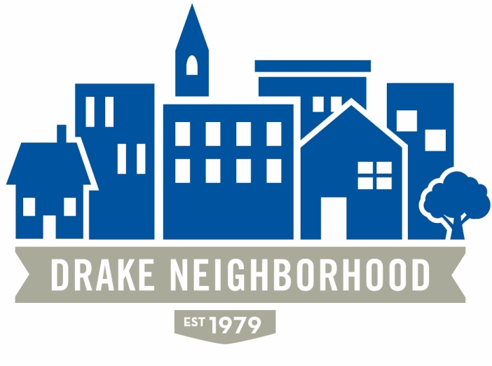
Board of Directors Meeting
Wednesday, August 10, 2016
7:00 p.m. to 9:00 p.m.
St. Catherine of Sienna, Drake University

Board Members Present (X)
 | Ibrahim Ali | X | Lori Calhoun | X | Michael Christl
X | David Courard-Hauri |  | Patty Daniels | X | Brian Dooley
X | Deric Gourd | X | Kristina Johnson |  | Sean Haire
X | Eldon McAfee | X | Eddie Robinson | X | Jen Sayers
X | Mark Schneider | X | Todd Slaymaker |  | (Student Senate Liaison)
X | Mark McKinney (NBSD) |  | Chris Reindl (NBSD) |  | Nick Valdez (Drake)

Introductions: 10 minutes

July Minutes: Jen moves approval, minutes pass.

Information:

NBSD: As classes begin in the fall, Drake will be resuming their extra policing, and that will be a nice addition to policing in the area. It is important to be vigilant as summer progresses: if you see suspicious activity, call it in. Sgt. McKinney will be doing a lot of the policing for Drake, so he will have even more presence in the neighborhood. Make his job easier by letting him know what’s up.

Broadlawns: Mary Krieg (Board Chair). They’re looking for board members, so if you know of anyone, check out their website. They are in a very good financial position right now—they just paid off a loan that was costing them $1 M in interest every year, so that was great to get out of the way—but, of course, there is a lot to do and there is always pressure to reduce funding. Every year they choose an area to focus on, and this year they chose behavioral health. They were able to remodel the inpatient psychiatric unit, which had been in very bad shape. They do have to prioritize because they don’t have enough beds for everyone, but they are working on that. They hope to add another 14 beds within the next year or so, mostly for patients who need long-term care because there aren’t really places for those patients any longer. They now have a mobile crisis unit focused on mental health which has been a nice addition. The unit can do evaluations and set people up with outpatient care and relieve pressure on hospitals while addressing mental health needs. She said that there are no psychiatrists south of I80 down to Missouri, so they provide a critical service. They also service patients who need dental care because most dentists don’t take Medicare. They will be opening a new clinic building which will open up in the spring of ’17. It will have dental, pain treatment, and other services. They hope to increase behavior health outpatient visits by 40%. They’re also opening up a new clinic on East University by the A&E Dairy to serve that population.

There is often a lot of pushback on their budget, so Mary pointed out that if you have a $200,000 home, $46/month in your property taxes go to support Broadlawns, which she called a bargain.

Sgt. McKinney pointed out that the mobile crisis unit is a huge benefit from a policing perspective, because in the past every time there was a mental health call it required two officers to wait with the patient for 4-5 hours, essentially using up their shift. If you assume that there will be multiple mental health calls at any given point, that’s a lot of police off the streets. Mobile crisis has fixed this problem, and saves a huge amount of officer time, thus allowing them to focus on crime.

Forest Ave. Economic Renewal Plan. Naomi Hamlet (City of Des Moines). TIF funding, though controversial, allows property tax abatement to and encourage development. It allows the developer to get a refund on some of the property taxes on value above the previously assessed value of the property. So, for example, if the property was assessed at $100,000 before, and after the improvement it is assessed at $200,000, the city can allocate the extra tax money from the additional $100,000 for various initiatives. In the case of the project on 32nd and Forest, The City is planning to assist with TIF. NDC will get a portion of the proceeds from the increased valuation for the first five years, and then the amount they get will go down 20% per year for the next five years. This is a way to encourage development. It used to be that all multifamily projects got 10 year tax abatement, but that has been significantly reduced in Des Moines (outside of the city center), and it is much more difficult to get. Because the City is interested in increasing development in the Drake area, they were able to get this funding done.

3201 Forest Ave. Project update. NDC. They removed some of the building at the southeastern corner to improve sight lines onto forest. They are trying to keep some of the trees on the west side to block the view of the stairwell. They’re also trying to make the central area a community focus. There now have 50 units (66 bedrooms) with 58 parking spaces. The entryways to the parking lot will be gated. Each unit has a washer/dryer, full appliances. Units will be renting at about $2/square foot ($820/month for one-bedroom). The traffic study suggested that they would increase traffic less than 0.5%. They expect construction to take 10 months.

Old Business: 15-20 minutes
1 National Night Out (Kristina). There were 200-250 people there—great turnout. The church to the west provided tasty side dishes, and the church to the east provided $250. Chris Hensley said it was probably one of the best NNO events this year, and may have been the largest Drake event ever.
2 Website (Todd). No new information. He reached out to the initial developers, but hasn’t heard back. He’ll try again and we’ll put it off one more month.
3. Financials (Mark). Nothing new.
4. DSM Neighbors (Michael). They are trying to get a viaduct for emergency response vehicles over the train tracks and Hull in the Oak Park area because emergency vehicles cannot respond in time when trains are in the area. Furry Friends is looking for ways to reduce animal kills at the shelter.
5. Farmer’s Market (Michael). The market has been going well, though we need more customers!
6. City Council Meeting (Deric). City Council approved adding

New Business: 10-15 minutes
- IMT Marathon. Dave will organize a water station, and there were a number of members who expressed interest in helping.

.

