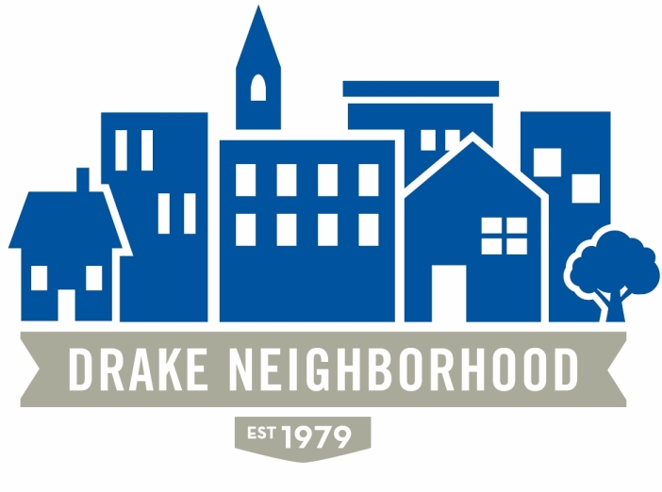
Drake Neighborhood Association Board Meeting
Wednesday, November 8, 2017
7:00 p.m. to 9:00 p.m.
Polk County Central Senior Center, 2008 Forest Avenue

Board Members Present (X)
X | Ibrahim Ali (12/18) | X | Nadia Alie (12/18) |  | Michael Christl (12/17)
X | Lori Calhoun (12/17) | X | Amy Clark (12/18) |  | David Courard-Hauri (12/17)
X | Deric Gourd (12/18) | X | Kristina Johnson (12/18) | X | Eldon McAfee (12/17)
 | Ashley Parker (12/18) | X | Eddie Robinson (12/17) | X | Nichole Aksamit Purcell (12/18)
 | Jen Sayers (12/17) | X | Mark Schneider (12/17) | X | Todd Slaymaker (12/18)
 |  | X | Mark McKinney (NBSD) |  | Jazlin Coley (Drake Student Community Action Board)
 |  |  | Chris Reindl (NBSD) | X | John Smith (Drake)

Note: All votes are in bold italics.

Introductions. There were multiple guests in attendance.
Minutes: approval of minutes for October. Motion passed.
Financials: Nothing new.

Parks and Rec: Developing Feedback for Masterplan: activity to generate input on features offered in neighborhood parks. Asked those in attendance to answer the question “What would you like to see in our parks if money were no object?” They will take feedback from neighborhood meetings to their Director and on to the City Manager. Top requested items were accessible restrooms, trails, lawn/event space and a shelter.

NBSD: Mark: 660 calls for service including 11 motor vehicle thefts. Mark reminded everyone to not leave cars running with the doors unlocked this winter. DMPD is recommending local online product service of https://mypropertyidregistry.com/ Anti-Theft system, Mobile Security and Lost and Found. It is a secure online database where subscribers can store the serial numbers of their property. Mark had flyers with a promotional code to waive the normal fee of $29.95.
Deric brought up concerns of increased homeless presence overnight in Drake Park, specifically sleeping in the shelter and bushes. Marc confirmed park hours are technically sunup to sundown and police should be called if/when people are in the park afterhours. However use of the basketball court after sundown is permitted because it is still lit (sounded like a “grey area”).

Property Updates:
- University Ave Project. Hearing set for next Council meeting on Planning and Zoning
- Liquor License for 1159 24th Street: License was granted.
- Deric advised in general planning and zoning concerns it is a good idea to keep up with their agenda to know what is going on in the neighborhood. Also, reminder that notification is only required for the residents within 250 feet of proposed change.
- Guest in attendance questioned DNA refusal of support for multiplex housing renovation on otherwise abandoned homes in the neighborhood. Deric assured the DNA is in full support of owner-occupied rehab homes and there are many resources like NFC to help with that, however in accordance with our 2010 Neighborhood Plan the homes will remain (or be converted to) single family with the exception of University and Forest Avenues.

Drake: John Smith, Vice President of University Advancement john.smith@drake.edu they are working to fill Nick’s position with over 100 applicants they are hopeful that they will have someone by early January.
This Tuesday the 14th they will have the Bucksbaum Lecture Series with Presidential historian and environmental conservationist Douglas Brinkley. Then later that evening the two remaining houses in the new development area will be moved to Sherman Hill.
Also in attendance, Chris Nickell, Director, Environmental Health & Safety chris.nickell@drake.edu Board certified safety professional offering to give safety presentations at future DNA meeting on topics like household safety, disposing of house hold toxins, etc. He is also willing to submit articles for DNA newsletters.

Old Business:
- Des Moines Neighbors Meeting: Lori: City Council candidates spoke.
- Business Partners Program. Amy has contacted Central Bank, no reply
- Marketing: Nichole: Next DNA newsletter will be out before Thanksgiving. DNA video project is “still a work in progress” the voice over work and a family interview will be done soon.
- Tree Planting: Over 30 volunteers attended on October 28th many saw the event promoted on Facebook and Nextdoor, 49 trees planted on Kingman Blvd and side streets.
- Community Garden: Eddie—still is looking to raise funds for a new tiller.
New Business:
- Drake Park new playground equipment is in and looks nice.
- Upcoming DNA board election, need to publish our nominees by the weekend. If we have any connect them with Kristina. Nichole will post on social media (done 11/9, thank you!) Succession planning, need new Secretary and VP for 2019
- Madison Kelly madison.kelly@drake.edu journalism student at Drake University writing a feature article for the Pedestrian centering on food deserts in the Drake neighborhood looking for someone from the board to interview about the neighborhood. Contact Kristina if you would like to be interviewed (11/9 update David will be interviewed, thank you David!)

Meeting adjourned 8:08

