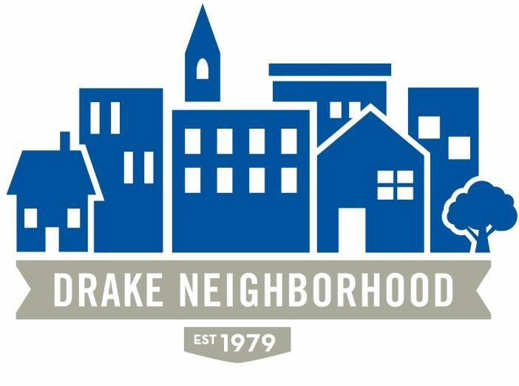

Board Members Present (X)
X | Ibrahim Ali (12/18) | X | Deric Gourd (12/18) | X | Jen Sayers (12/19)
X | Nadia Ali (12/18) | X | Kristina Johnson (12/18) | X | Erin Sears(12/19)
X | Lori Calhoun (12/19) | X | Eldon McAfee (12/19) | X | Mark Schneider (12/19)
 | Michael Christl (12/19) | X | Nichole Aksamit Purcell (12/18) | X | Todd Slaymaker (12/18)
X | Amy Clark (12/18) | X | Eddie Robinson (12/18) |  | John Smith (12/19)
 |  | X | Mark McKinney (NBSD) |  | Eric Barker (NBSD)
Drake Neighborhood Board Meeting Minutes: Wednesday, April 11, 2018, Forest Ave. Center
Note: All votes are in bold italics.

6:30 Board Business
Jen met with Supervisor Mauro, Bill Gray and Ben Page about the Witmer park project and would like to discuss this privately with the board before rolling out to the neighborhood. How do we designate time to talk about private matters and hold public meetings?

DNA board has been asked to reimburse expenses for inaugural committee meetings.
Deric--Motion for policy to approve kickoff committee meeting budget for recruitment treats if prior approval is granted for up to $25
Lori second, all in favor.

Approval of Agenda and March Minutes- All approved

Financials – Mark- no change

Meeting times- Jen requesting latitude to start meetings at 6:30 to accommodate guests and be out of the community center by 9PM. While important to maintain transparency during general meetings this would be a way of addressing “board issues” prior to guest and general membership attendance.

Jen- Walking tour of homes for Drake students Sunday May 6th. Lori and David have volunteered their homes. We are still looking for one more home. Possibly seeking a home with young children.

Rodine Mickle Neighborhood Appreciation dinner will be on Tuesday April 24th at the Ding Darling Shelter - can anyone attend? Amy can attend.

Planning and Zoning meeting--1107 24th was not rezoned; it is still R1-60.

Eric had black plastic bags of leaves removed from Kingman Blvd.

Rally in the Alley - Volunteer Project for Memorial Day Weekend – Walnut Creek Church
volunteer group will be cleaning up the alleys in the neighborhood Memorial Day weekend. Lori contacted the city to request additional trash pickup, has not heard back yet. Many board members agree Saturday would be the best day to focus the event. Erin would like to see as many Drake students as possible involved in the event.

7:12 Neighborhood Updates
Introductions

Guest: Senator Matt McCoy- Running for County Supervisor(June 5th) on the issues of mental health, substance abuse treatment, ready to make the case for treating substance abuse treatment rather than incarceration. Working with Josh Mandelbaum on water quality, currently we are 23% above EPA safe nitrate level, which is 10. Matt would like to provide strong, political leadership. He believes his role would be to care for the most vulnerable citizens, more transparency and needs to work on food scarcity issues. Discussed Water Works lawsuit and point source pollution. Matt will be an advocate for clean water.

NBSD: Mark McKinney- 617 calls for service in the last 30 days, 17 part 1 crimes. Forest Ave will be closed starting April 26th for the Drake Relays from 25th street to 30th to make the events more walking friendly. Mobile Command Unit will be on site during relays.

Guest: Jeff Horner and business partner Kevin Babb(realtor and investor), owner of 1120 26th Street Property-currently boarded up and has been on market 9 months. 4 DNA board members have toured the 5100 sq. ft. home formerly an 11 plex. Kevin and Jeff are requesting DNA support to approve R4 multi-family zoning 3 plex.
House is in really bad shape, and will take a substantial financial investment. It is being sold for cash. Mark Holcamp and Seth Crouch are willing to purchase the home on the condition that it can be rezoned to allow 3 plex.
The lot is 1/4 acre. Asking for a compromise from the DNA. Currently the home has been boarded up and has had homeless people living in it in the past.
Deric brings up issue that R4 zoning could allow future owners to increase units and it could creep back up to 11 units.
Jeff and Kevin will push through with trying to rezone whether we support it or not.
Deric would recommend keeping it R1-60 but apply for a variance to make it a 3 plex
Jen has talked to the city staff about a variance.
Mark McKinney suggestion: have the property manager go to Crime Free Multi Family Housing Program class with Shawna.
Motion- Do not support R4. We recommend property remains R1-60. We would support a zoning variance pending participation in Crime Free Multi Family Housing class. Majority in favor. Motion carries.

Councilwoman Connie Boesen: what can we do now that the tax vote did not pass?
FYI: The Print Shop offers competitive pricing to non-profits.

Des Moines Neighbors Meeting – Erin - focused on Rodine Mickle dinner.

Drake Update – Jen - road races and Beautiful Bulldog contest will be Sunday the 22nd. Spruce Up Event will be 25th starting at the Walgreen’s parking lot 5:30PM picnic at Drake Park following. Nichole sent it out on the email blast this week and it is on Facebook and Nextdoor as well. Community event pass will work for some relays events. Alumni event: let Jen know if you would like to go. Drake asking for a 5 year special event permit to use the parking lot across from Olmstead for up to 4 mobile vendors.
Lori - Recently finished a grant application to work with Drake students on how to improve partnership with the students. Approval/funding will be awarded in June.

Marketing update—Nichole
VIDEO ROLLOUT: After the last meeting, we posted the new Drake Neighborhood videos on Facebook, Nextdoor, You Tube, our website, and blasted them out to our expanded e-blast list. Jennifer kindly sent them in personalized emails to a targeted list. And we boosted the video posts on Facebook. (Boosts are paid promotions that push our posts out into the Facebook feeds of people we target — mainly adults in Des Moines and the friends of people who already like or follow our page.) Those small Facebook boosts (about $35 worth) reached more than 10,000 people, according to the post-campaign results. And the 3-minute and 30-second videos we posted on Facebook have had a combined 7,200 views. We had lots of nice engagement with those videos, too — likes, loves, smiles, shares, and comments. YouTube videos themselves had about 250 views; and people would largely have been directed to them from the e-mail blasts to our website, which had YouTube embeds of the videos.
FACEBOOK PICKING UP: Facebook has been busy and active in general for us these past few weeks. I’ve posted about some neighborhood news and upcoming events (including a tree pruning clinic at Drake Park on Thursday— thanks, Eddie!). And we had loads of discussion this past weekend on a Register story about a proposal to narrow University in the Windsor Heights area. Boosts in general have helped (about $60 total this first quarter). And we’re up to 926 likes and 914 follows on Facebook—still not over 1K, but headed in that direction.
WEBSITE ANALYTICS: Bill Cappuccio kindly helped me activate both a Google Analytics and a Monster Insights plug-in we already had on our site so we can track visits there. It happened a smidge too late to capture the initial effects of our video sharing, and we don’t have any historical data, but it should be helpful going forward. Monster shows we had 938 page views in the last 30 days, with Facebook being a primary driver.
SPRING CLEANUP EVENT: I’ve been working with Amanda Martin at Drake to pin down details of the pre-Relays cleanup, which now will conclude with a social gathering in Drake Park. We’re calling it the Drake Neighborhood Spring Spruce-Up & Social. Amanda is working with two groups of students, who will also publicize and attend the event (they’re planning some printed flyers and their own social media), and the University is providing gloves and trash bags and refreshments. They’re focusing on three primary routes: Greek Street (34th between University and Forest), 31st Street (University to Forest), and University (31st to 24th). And if there are enough volunteers, they’ll also hit the side streets south of University between 31st and the park. I drafted some promo language for the event, created a map, and posted the event on Facebook and Nextdoor this weekend/Monday, and Bill sent it around in e-blasts yesterday. I will do another paid Facebook boost ahead of the event. WHAT YOU CAN DO TO HELP: Please RSVP to the event on our Facebook or Nextdoor to help promote it (more RSVPs net more RSVPs) and help organizers get a headcount. Tell your friends and neighbors who might not be on those platforms. Also: Would at least one of you who is attending take some photographs/videos at this event (and from Relays, for that matter) and share with me/Katelin/Jennifer for Facebook and the newsletter? I will be out of state on vacation all that week.
NEWSLETTER: Please send me any ideas, notes, calendar updates (Do we know for sure if Coco is our movie? And do we have a Kingman Island Cruise date/location yet? Anybody pinned down the Rally in the Alleys event details with Walnut Creek Church volunteers for Memorial Day weekend), Good Neighbor Award nominations, etc., by May 1. … Katelin and I will be tackling the newsletter in earnest the first weekend in May and aiming for a mid-May publication, including our first batch of printed physical copies. SPEAKING OF: I did confirm with Copycat Printing that they’ll do the discounted printing with us in exchange for a Gold Level business sponsorship. I have their logo to start including on marketing materials and the newsletter itself.
MERCH: We’re about out of DNA logo T-shirts. I have shirts for Erin and John. I think everyone else on the board has them already. If not, let me know. After that, there are only about a dozen left (and some of the old 30th anniversary shirts). Can we reorder to have some to sell and use as incentives for campaigns this year? Do we want to wait and print something special for the 40th anniversary? What other kinds of merchandise should we have? Welcome Committee was asking about logo stickers that could be used on treat bags or cookie tins, or cool coffee mugs for welcome gifts—things that wouldn’t be size-specific. I believe Jen’s got this on the May meeting agenda, but do be thinking of what kind of merchandise we should have.
COMMITTEE LIAISON REPORT FOR THE DNA APRIL MEETING:
The DNA Welcome Committee is launched! One volunteer responded to our volunteers-needed posts. I snagged one more from the attendees at our last meeting and reached out to several others who took our survey last year. The co-chairs are Ryan Arnold and Ashley Baker. Other members are Stephanie Brennan, Lucy Fitzgerald Wendel, and Alex Baranosky. I organized a kickoff meeting with them last week at Mars Cafe. They have their marching orders and are working on mapping out what a welcome process would look like, how to identify and connect with new neighbors and members, and how to connect interested newbies with volunteer opportunities. They’re aiming to meet monthly at least to start. I will not be serving ON this committee, but I will check in with them ahead of our meetings and share updates. ONE REQUEST: As thanks and incentive (and to set the tone for the welcome committee!), I offered to buy coffee for those who showed up at the kickoff meeting. I didn’t know we’d even HAVE a committee at the last board meeting, so I couldn’t get your pre-approval. But the group was small, not everyone wanted a beverage, and the bill was negligible. Might the DNA reimburse me for $13.80 for refreshments at the launch of this committee?

Payment of Refreshments for DNA Meetings restated new policy

Meeting Adjourned__________________8:50PM_________________

