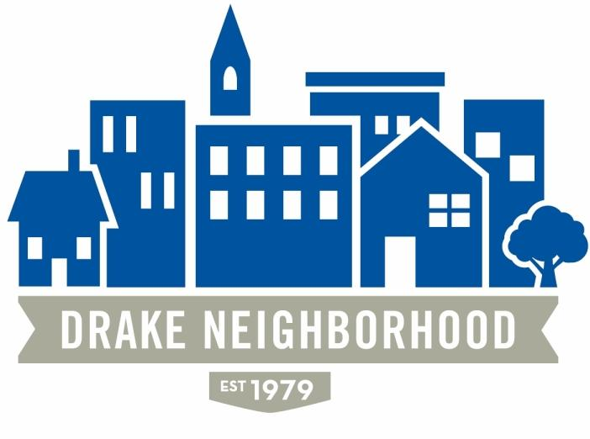
Drake Neighborhood Board Meeting Agenda:
Wednesday, April 10, 2019—Polk County Center at 6:30 pm

6:30 Board Business

Approval of Agenda, March Minutes
- Mark made a motion to approve the agenda and minutes. Matt seconded. Motion carried.

Financials – Mark
- Checking: $1,337.26
- Savings: $20,570.55

Des Moines Neighbors – Carl
- Membership Paid
- Membership is welcome to attend the Potluck Event. Jen sent out the event information in an email.
- Nominations
  - Public – Colby for Witmer Park
  - Business – Bank of Iowa or The Library
  - Volunteers – Kevin and Carole Venhaus

Witmer/Flicks Report – Jen
- The Go Fund Me page is set-up and information regarding the park improvements is available.
- The Beaverdale Neighborhood Association contributed $2500.
- The DNA agreed to match Beaverdale’s pledge with $2500: Erin made a motion to approve. Eddie seconded. The Board agreed to take it out of savings. Motion carried.

40th Anniversary – KJ
- Grant to be decided by the end of April.
- Event Date is September 28th.
- The main band is Stark Raving Madge: Soul Searchers was recommended as an additional band. It was also suggested to follow up on Glitter Density (local to Drake) Potentially looking to Lefty’s or Toby to sponsor the Stage.
- Drake’s Communication/Publications class is developing slogans, radio announcements, twitter, social media. Met on April 1st. Will meet again on April 24th .

Marketing Update—Nichole
- Budget Request – $750. This will cover printing costs (Nichole negotiated a printer at cost), social media boosts, Welcome Committee needs, support for major events, etc. Carl motioned to approve. Matt seconded. Motion carried.
- Neighborhood clean-up on Wednesday, April 17th 5:30 at Walgreens

Membership/Welcome Update – Matt
- Matt provided a brief update on using sign-in for membership follow-up.
- He asked if anyone interested in helping with moving membership forward to contact him.
- Erin, Matt, Carl and Nicole had volunteered to help with Membership and Welcome committee

Committee Event Budgets:
Beautification: Eddie, Michel, Mac, Kevin,
- Funding - FYI: Cottage Grove Triangle may receive funding through the Revitalization Pilot. If anyone is interested in being part of the pilot program contact Lori.
Flix: The plan is to start early and provide food and games regarding the Witmer Park improvements.
Drake/DNA Awareness: Eddie
Everyone on 40th
NNO - Eddie

Claire Celsi attended to hear what the neighborhood was up too. Legislation session is coming to an end. Claire is available if you need anything! She commended the DNA in doing an awesome job in remaining active!

XkB Concert in Drake Park – no discussion

Construction on Cottage Grove – any updates? Concerned if the Nelson Construction starts up if there will be limited accessibility to homes. Not update was available.

7:00 Neighborhood Updates

NDC Report – Abbey Gilroy
- Abbey shared NDC’s plans to renovate the Crazy Horse Guitars building. Originally a surgeon’s office and then Putman Rexall Pharmacy. Great History. Intending to improve the parking, dumpster enclosure, site improvements, street improvements, keeping and adding plantings. They intend to peel the skin back and return to brick. It will house a new restaurant along with the NDC offices on the 2nd floor. Mural potential for the building? Preop with the city has gone well. Open by November. Jennifer will be kept informed on progress.

Guest: Siobhan Harman, Kum & Go
- Remodel the Kum & Go on 31st and University
- The building will move to the corner of 31st and University (Des Moines Code change – allows us to bring building up to the street.)
- An apt building on 31st Street was purchased to increase the location’s footprint. Current residents are a short-term lease and given adequate lead time to relocate. Relocation assistance will be provided.
- Entrance on University will be the same and the entrance on 31st will be as far south as they can make it.
- The fuel canopy will be located on the west side facing LSI. Landscaping will be added to buffer LSI.
- Amenities include a bike rack, dumpster enclosure, storm water retention, LEED compliant buildings and expanded food options (moving toward fresh foods)
- Have not proceeded with the pre-planning meeting with the City
- The station will be closed during the process. They will not start before May graduation
- Neighbor feedback was primarily on the exterior. Less white and more natural brick, is possible!

Guest: Tobi Parks, xKb update
- Not present

Guest: Mark Kilian, Property owner at 1329 33rd St.
- Tom Franklin/Mark Kilian attended to discuss plans for a lot that has been vacant for 30 years. The lot is currently owned by the Sigma Chi House organization. They were looking to find a use for the lot and determined to build an investment property. The Builder is Evergreen Homes – alumni of the fraternity. A duplex was approved – if several conditions were met. There was concern expressed from neighbors on the plan.
- Recommended meeting with the neighbors and engage on their interest and their feedback.
- Procedural: Final plans will go back to zoning, staff will approve the plans if they meet the architectural standards…applying for a permit.

Drake Report – John/Ryan
- Upcoming activities for the Drake Relays
- Provocative Conversations – Lisa Ling
- Neighborhood night at the Relays – Thursday Night.

NBSD: Mark McKinney and Eric Barker
- Calls for Service – way down!
- Preparing for Drake Relays
- Problem property 27th street – narcotic concerns: names and tools to manage directly were provided.

Meeting Adjourned___________________________________________

