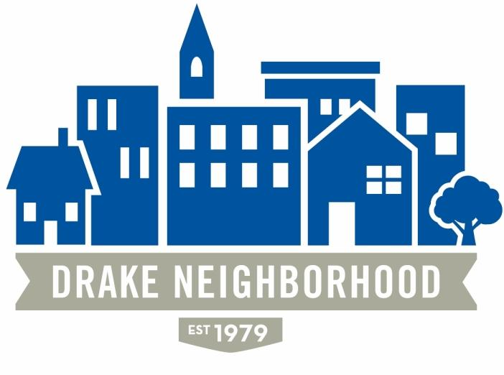
Drake Neighborhood Board Meeting Agenda:
Wednesday, September 11, 2019—Polk County Center at 6:30 pm

Attendees: Erin Sears, Nichole Aksamit Purcell, Jason Struyvesant, Tom Biedenfeld,
Matt Moore, Eddie Robinson, Jr., Mark Schneider, Kristina Johnson, Carl McPherson,
Richie Allen, Eldon McAfee, Jennifer Sayers

6:30 Board Business

Approval of Agenda, Previous Minutes – Motion Mark, Second - Matt

Financials – Mark $936.44 Checking, $18,575.37 Savings

Des Moines Neighbors – Due to a lack of participation, they’d like to move to
quarterly meetings and have tabled discussion until after November elections.

Carpenter Neighborhood Secedes – Nichole made a motion that Carpenter residents
continue to be served by the DNA. Tom/Mac to write letter to City. Second – Jason.

40th Anniversary – KJ – Permits applied for and coming. Need vendors. Need
posters/flyers, Nichole and KJ to work on this. KJ/Jason bringing tables, last minute
details.

Marketing Update—Nichole Website updates continue – Jason and Nichole to work directly with Angie to finalize, 40th marketing, event details/merch tent – need volunteers to staff table, bring chairs.

Membership/Welcome Update – Matt

7:00 Neighborhood Updates

Mayoral Candidate Joe Grandanette – spoke to attendees about his goals as mayor.

Mallory Wentlund – Ramsey Village – spoke to attendees about their
events/partnership with DN.

City Council Candidate Marlon Moorman - spoke to attendees about goals as mayor.

Ryan Arnold, Drake – October 3 house move. Community Passes now available for
pick-up at Ticket office, update on Boys & Girls Club opening. 150+ accepted to
program, hoping for 250 students.

NBSD: Mark McKinney and Eric Barker – Calls for service have increased, as have
shots fired. Neighbors are speaking up, which has assisted in arrests. Robberies are up,
but neighbors are calling in with information. Thank YOU – when you call it in, it
works! Stay vigilant, keep lights on, use cameras, let neighbors and police know when
you are away from home. Bulldog Alerts or similar community service options were
discussed. Ryan to check.

Bliz on Blight underway, fire-damaged homes getting attention, yard parking and junk
in yards is looking better.

City Council Candidate Ethan Standard - spoke to attendees about his goals as mayor.

June Owens – candidate for School Board.

Jaime Izaguirre – Drake Comrades – leftist group on campus working on housing
justice. Would like to see Neighbors working with them on tenants’ rights and concerns
about development and gentrification. Asked if we could create a Student Membership
level of $5.

Meeting Adjourned 8:50pm

